|  |  |  |  |  |  |  |  |  |  |  |  |
| --- | --- | --- | --- | --- | --- | --- | --- | --- | --- | --- | --- |
| **Department of Information and Communication Technology** | | | | | | | | | | | |
|         **I declare that I am familiar and will abide with the Assessment rules as indicated in the Sol Plaatje University Rules Book**              **_____________________**    **Signature** | **COURSE NAME: ICT Electives II/Human Computer**  **Interaction**  **COURSE CODE: NITE63410/NHCI63110** | | | | | | | | | | |
| **Class Test 1**  **Due Date: 09 April 2025**  **Total Marks: 100**  **Total pages: 4 (including cover)** | | | **Name of Examiner Mrs. K.E Mamabolo** | | | | | | | |
| **Name of Moderator Mr. Phumezo Ntlatywa** | | | | | | | |
| **Student number** | **2** | **0** | **2** | **3** | **2** | **7** | **9** | **7** | **7** |  |
| **Surname**  **Maebela Andile Thuso** | | | **Initials**  **A.T.N** | | |  | | | **%** | |

**Part A: Discovering Requirements**

**1. Identifying a Real-World Student Problem Space**

Many students struggle with **poor time management**, leading to missed deadlines, inefficient study habits, and stress. Balancing assignments, exams, and personal wellness can be overwhelming, resulting in **academic burnout**.

Students usually have deadlines that overlap, which makes it difficult for them to plan ahead or produce high-quality work. Anxiety is increased by the absence of proactive reminders, which results in last-minute cramming and poor performance. Prioritisation becomes reactive rather than strategic in the absence of tools for visualising timescales.

Students often sacrifice sleep, meals, and breaks for academics, neglecting physical and mental health, leading to decreased focus, motivation, and academic satisfaction due to the absence of integrated wellness prompts.

Missed notifications regarding rescheduled classes or deadlines result from relying on several disparate technologies (email, WhatsApp, Instagram and Facebook). Due to inadequate information consolidation, students without dependable organisational methods run the danger of falling behind. These mistakes could be avoided and needless academic sanctions could be decreased with a centralised solution.

A solution is a **"Wellness and Welfare StudentLife"** – an app that integrates study reminders, wellness check-ins, and productivity tracking.

**2. User Research (Interviews Summary)**

I conducted brief interviews with TWO students:

* **First Student (Final Year, ICT)**: Struggles with tracking assignment due dates and managing his personal stress. Prefers digital reminders.
  + Has to constantly keep contacting family and family relatives because he is always forgetful with communicating and checking their well-being.
  + Always buys the wrong groceries and stationary when going shopping.
  + He is having trouble adapting to the academic environment and how to manage where he spends most of his time being.
* **Third-Year Student (3rd Year, RBM)**: Often forgets class schedules and finds it hard to balance coursework with personal life. Needs structured planning.
  + He is always confusing class test and keeping track of his Basketball matches he has to play.
  + He has to manage being a Tutor and make suitable times to have classes with students and prepare work they can do to show if they are progressing in understanding the topics he is tutoring.
  + Mixes up the scheduled group project meeting especially when he has numerour projects he has to complete in a certain time.

**3. Personas**

**Persona 1: Thabo – The Overwhelmed First Year Student**

* **Age**: 19
* **Course**: Dimploma in ICT
* **Challenges**: Balancing projects, time management for studies, and job applications.
* **Needs**:
  + A structured way to manage communications with people and when appropriate to do so.
  + Organized grocery list to manage shopping periods

**Persona 2: Tlhalefo – The Forgetful Business Student**

* **Age**: 22
* **Course**: Diploma in Retail Business Management
* **Challenges**: Struggles with remembering schedules, deadlines and test and exams.
* **Needs**:
  + Ability to create reminders for classes, tests and tasks.
  + Manage his personal life and work life while also not spending too much time organizing both his lifestyles

**4. Usage Scenarios**

**Scenario 1: Assignment Management**

Thabo logs into the app and sees **upcoming deadlines**. The app makes it more convenient to manage tasks and projects on a daily basis.

**Scenario 2: Wellness Check-In**

Tlhalefo receives a **daily wellness reminder**. He completes a **reminder and when he hovers over the reminder it shows a description of the reminder**. This will help summarize the reminder in the Dashboard and make the description more accessible.

**Part B: Designing the Conceptual Model (30 Marks)**

**1. Core Functionalities**

* **Smart Reminders**:
  + Push notifications for deadlines, classes, and breaks.
  + See the Due Date of reminder.
  + Description of reminder appears when you hover over reminder.
  + The date and time of when the reminder was made.
* **Wellness Check-Ins**:
  + Mood tracking & mindfulness suggestions.
  + Personalized homepage that exclusively only displays your reminders only to your account registered with.
  + Ability to create unlimited reminders for your personal needs.
  + You can delete a reminder if you’ve already finished doing it or if it’s been rescheduled.
* **Class Schedule Organizer**:
  + Displays upcoming tutorials, classes and assignments.
  + Shows you the date of your scheduled tasks and projects.
  + Organized display of reminders by arranging reminders with the closest deadline at the top of the homepage

**2. Interaction Types**

* **Instructing**:
  + Users input study tasks, their description and due date.
* **Conversing**:
  + Easy accessibility to see tasks and their description.
* **Manipulating**:
  + Delete tasks when you’ve completed them or their date has passed.

**3. Interface Metaphor**

* **"Personal Academic Assistant"** – The app acts like a **digital wellness monitoring coach**.

**4. Conceptual Model Diagram**

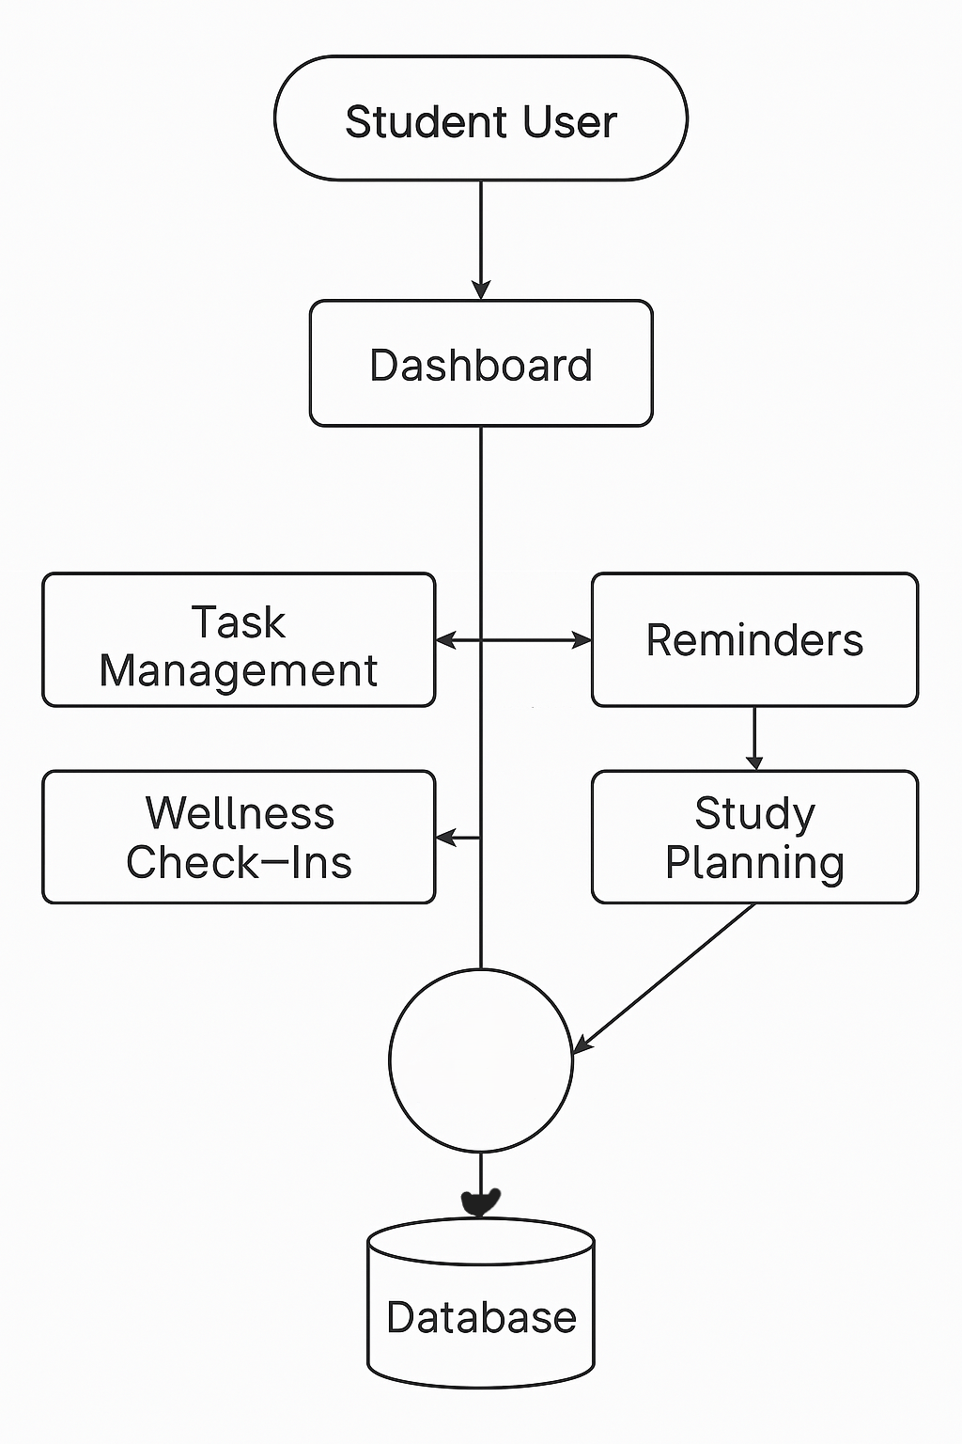

Homepage

**Part C: Interface Sketching & Django Wireframe (25 Marks)**

**1. Sketching (10 Marks)**

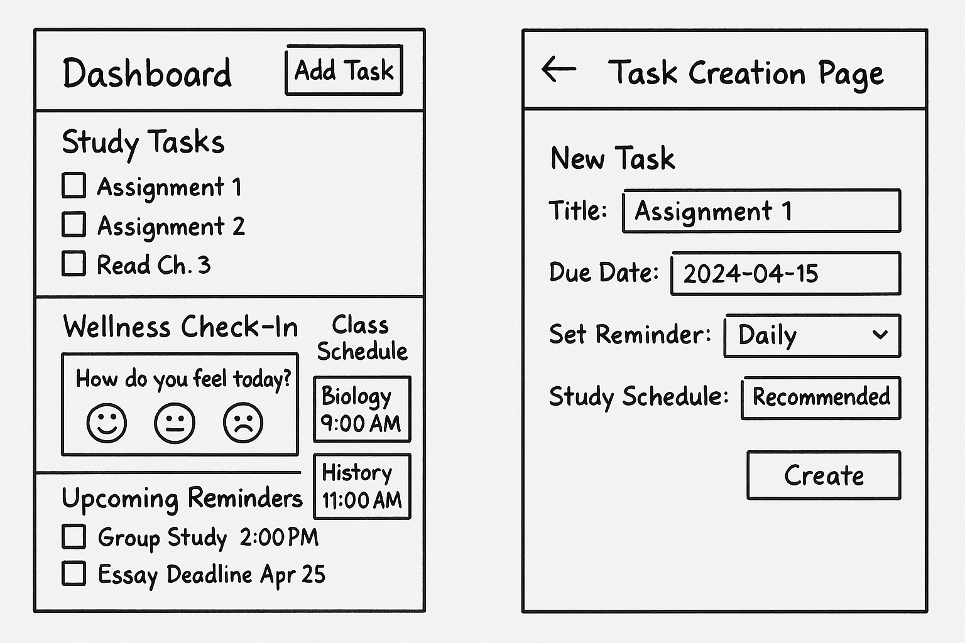

**2. Django Wireframe (15 Marks)**

**Django Project Setup**

1. **Set up Django project** (studentLife_app).
2. **Create an app** (base).
3. **Develop a basic view** (home.html for the dashboard).
4. **Add a form for task creation** (create_reminder.html).
5. **Include URL routing** (urls.py).
6. **Deploy a simple model for task management** (models.py).

**Deliverables:**

* **GitHub link** to the Django project.
  + <https://github.com/Thuso-him/StudentLife-WWW.git>
* **Screenshots** with explanations

The user sign-up page to have ability to access the system.

The user log-in page to verify and validate if the user is registered into the system.

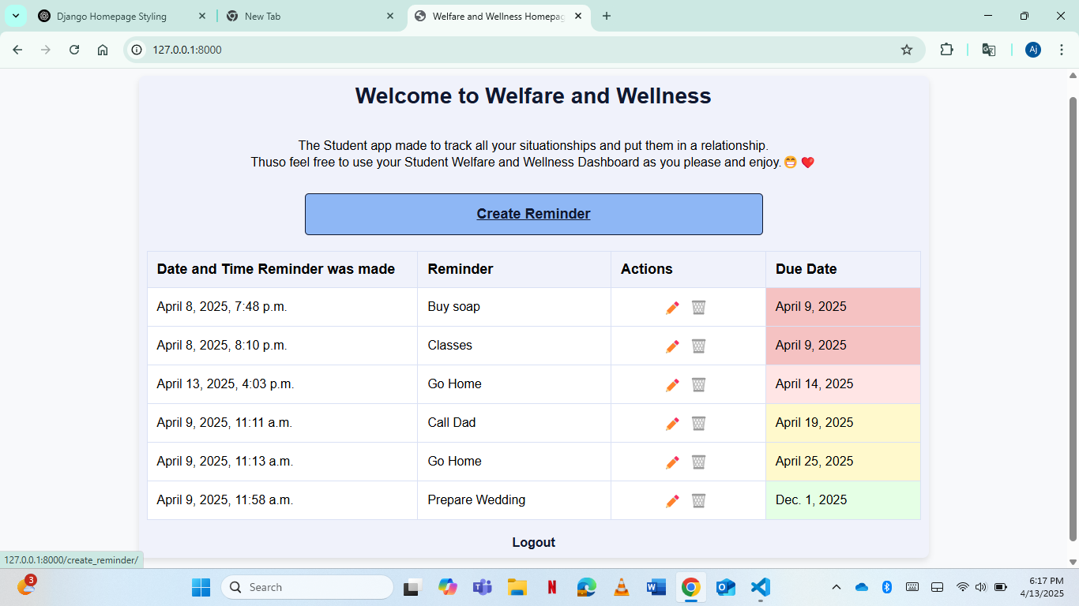

The user’s personally configured homepage based on his own created reminders previously.

The page that allows users to create new reminders that will appear in the homepage.

**Part D: Evaluation Planning (15 Marks)**

**1. Usability & UX Goals**

* **Usability Goal 1**: Ensure **ease of use** – students should quickly add and track assignments.
* **Usability Goal 2**: Ensure **clear navigation** – users must find key features without confusion.
* **UX Goal**: Reduce **stress** by integrating wellness tracking & academic workflow management.

**2. User Testing Questions**

1. How easy was it to add and manage tasks?
2. Were the reminders helpful?
3. Did the reminders organizer improve focus?
4. What improvements would you suggest?

**3. Evaluation Method**

To assess the usability and overall user experience of the Wellness and Welfare StudentLife app, the **Think-Aloud Protocol** will be utilized as the primary evaluation method.

**Think-Aloud Protocol** is a qualitative usability testing technique where participants are asked to verbalize their thoughts, feelings, and decision-making processes as they interact with the application. This method helps uncover user frustrations, confusions, and expectations in real-time, which may not be captured through post-task interviews or surveys.

During the evaluation, users will be given a set of tasks to perform, such as:

* Creating a new reminder for an upcoming assignment.
* Completing a wellness check-in.
* Viewing and interpreting their upcoming class schedule.
* Editing or deleting an existing task.

As they complete these tasks, users will be prompted to speak freely about what they’re thinking — for example, if they are confused by a button, pleasantly surprised by a feature, or unsure about where to find a function.

All sessions will be observed (either in-person or remotely via screen sharing), and notes will be taken on where users struggle, hesitate, or require clarification. These insights will then be categorized and analyzed to improve the interface, navigation, and overall experience.

**Why this method?**

* It is cost-effective and easy to implement with a small group of users.
* It provides rich, qualitative data about how real users interact with the system.
* It aligns well with the student-centered focus of the app, allowing developers to directly observe whether the app reduces stress and simplifies academic planning.

**Post-Evaluation Follow-up:**

After the Think-Aloud session, a brief interview will be conducted to gather additional feedback, clarify any unclear observations, and ask for suggestions. This combination of real-time observation and reflective feedback provides a comprehensive understanding of the app’s usability and impact.

**Part E: Reflection (10 Marks)**

**Reflection (300-400 words)**

Working on this assignment has provided a meaningful introduction to the real-world application of user-centered design principles. From identifying the problem space to conducting interviews and crafting personas, each step highlighted how vital it is to truly understand user needs before diving into development. The problem of student stress, poor time management, and difficulty in balancing academic and personal life is a universal challenge. Creating a digital solution like *Wellness and Welfare StudentLife* allowed me to explore how design can be both functional and empathetic.

One of the main challenges was ensuring that the app didn’t become another overwhelming platform for users. Students are already juggling various tools and expectations, so the focus was on simplicity, clarity, and relevance. Developing the conceptual model helped me map out the flow of interaction and confirmed that features like reminders, mood tracking, and schedule management could be seamlessly integrated. The idea of hoverable descriptions for reminders and prioritizing tasks by due date came directly from understanding how students think and behave under pressure.

Sketching and wireframing allowed me to visualize the core functionalities and make necessary changes before moving into the technical build with Django. Though setting up the Django project required careful planning, the use of simple templates and a structured view model made implementation smoother. Still, I realized how important it is to test the interface with real users — what works well in theory may not always translate to practice.

Looking forward, I see great potential for evolving this app further — incorporating features like push notifications, calendar syncing, and even AI-driven study plans based on personal productivity patterns. Most importantly, this project reaffirmed the idea that good technology doesn’t just solve problems; it improves lives. By combining academic planning with wellness support, the app reflects a more holistic approach to student success. It’s not just about meeting deadlines — it’s about thriving while doing so.